**Element Dossier: Fluorine (F)**

**Element Information**

| *Physical Properties*  State of matter: Gas  Color: Very pale yellow (Alpha is opaque, beta is transparent)  Density: 1.696 g/L  Molar mass: 18.998 g/mol  Boiling point: (F2) -188.11 °C  Melting point: (F2) -219.67 °C | *Chemical Properties*  Reactivity towards air: High (Reacts with moisture in air but does not react with O2 or Nitrogen)  Reactivity towards water: High. (Forms Hydrofluoric acid and oxygen)  Flammability: high  Preferred oxidation state(s): -1, 0 (Oxidizes oxygen) |
| --- | --- |

*Shell diagram and Lewis dot symbol*

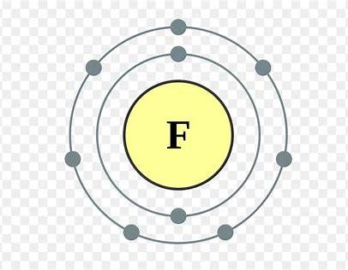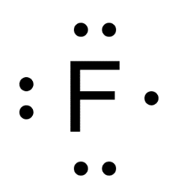

*History and Name Origin:* While Fluorine the element was not officially recognized until later, the first uses of it were in that of Fluorite, Fluorine’s source material. It was first described by Georgius Agricola. Its recognition came later in 1810 when André-Marie Ampère suggested that Hydrofluoric acid was a compound of hydrogen and an unknown element analogous to chlorine. Sir Humphry Davy was the one to coin the term Fluorine, taking the root from the name of fluoric acid and adding the -ine suffix, thus bringing it in line with the other halogens. The first success at isolating the element came in 1886 when Henri Moissan electrolyzed a mixture of potassium fluoride with hydrogen fluoride. While large scale production would not take place until the 1940’s as part of the Manhattan Project, the main fluorochemicals were commercialized by the DuPont Company to create the refrigerant gases (Freon) and polytetrafluoroethylene plastic (Teflon).

*Distribution and Uses*

Locations: Top 3 Producers are China, Mexico, South Africa

Uses: Fluorine is used most commonly today by the steelmaking industry. In the 1940’s, Germany used high-temperature electrolysis to make tons of the planned incendiary Chlorine Trifluoride. The Manhattan Project used large amounts to produce Uranium Hexafluoride for Uranium enrichment to gain Uranium-235. Which today is used for clean burning nuclear power.

Obtaining and Purifying: Fluorine is the 13th most common element in the Earth’s crust at 600-700 ppm. Most fluorine exists as fluoride-containing minerals such as Fluorite, Fluorapatite, and cryolite.

U + 2 ClF3 → UF6 + Cl2

**Compound Information**

*Compound #1: Uranium Hexafluoride*

| *Physical Properties*  State of matter: solid  Color: Colorless  Density: 5.09 g/cm3  Molar mass: 352.02 g/mol  Boiling point: 56.5 °C  Melting point: 64.05 °C | *Chemical Properties*  Reactivity towards air: Stable  Reactivity towards water: Hydrolyzes  Flammability: Non-flammable |
| --- | --- |

Chemical Structure and Description of Bonding

| Skeletal structure of UF6 | This is a covalent compound. It contains a set of six covalent bonds. |
| --- | --- |

Compound Uses: Uranium Hexafluoride is used in the process of enriching uranium which produces fuel for nuclear reactors and nuclear weapons.

Relevance to Target Audience: Our audience of nuclear power companies will gain strongly from using this compound in creating clean burning power for everyone. After all, you can’t create nuclear power without uranium and you can’t have uranium without Fluorine.

*Compound 2:*

| *Physical Properties*  State of matter: Solid  Color: White  Density: 1.78 g/cm3  Molar mass: 64.03 g/mol  Thermal Stability: Stable | *Chemical Properties*  Reactivity towards air: Stable  Reactivity towards water: Stable  Flammability: Non-Flammable |
| --- | --- |

Chemical Structure and Description of Bonding

| −(C2H2F2)*n*− | This is a highly non-reactive thermoplastic fluoropolymer. |
| --- | --- |

Compound Uses: A short list of places this could find itself in the home is in electrical components and batteries. The construction and architecture of the home. And in water and waste management.

Relevance to Target Audience: This is an absolute must have for any self-respecting homeowner! This stuff will build your house and then pipe you water and wire you electricity! What else could you want?

**Bibliography**

1. National Center for Biotechnology Information. "PubChem Compound Summary for CID 24524, Fluorine" PubChem, https://pubchem.ncbi.nlm.nih.gov/compound/Fluorine. Accessed 4 October, 2021.
2. “Fluorine - Element Information, Properties and Uses: Periodic Table.” *Fluorine - Element Information, Properties and Uses | Periodic Table*, https://www.rsc.org/periodic-table/element/9/fluorine.
3. “History of Fluorine.” *Wikipedia*, Wikimedia Foundation, 23 Aug. 2021, https://en.wikipedia.org/wiki/History_of_fluorine.
4. “Fluorine.” *Wikipedia*, Wikimedia Foundation, 15 Sept. 2021, https://en.wikipedia.org/wiki/Fluorine.
5. “Uranium Hexafluoride.” *Wikipedia*, Wikimedia Foundation, 14 Aug. 2021, https://en.wikipedia.org/wiki/Uranium_hexafluoride.
6. “Polyvinylidene Fluoride.” *Wikipedia*, Wikimedia Foundation, 4 Oct. 2021, https://en.wikipedia.org/wiki/Polyvinylidene_fluoride.